**METHODS YEAR 12 Test 3 2017 Name:________________________**

**Anti-Differentiation**

**Resource Assumed Time: 25 minutes Marks: / 25**

**CAS calculator + A4 page 1 side of notes**

**Question 8 (8 marks)**

Sam has invested $*A* in a fund which compounds her investment continuously at a rate of *k* % per annum.

The rate of change of her investment is given by  where *V* is the value of her investment in dollars and *t* is the time in years.

The net change in the value of her investment in the first 10 years is $12 331 . 78.

The net change in the value of her investment in the next 10 years is $22 469 . 97.

1. Determine the values of *A* and *k*. (6 marks)
2. Hence determine the function that defines the value of her investment.

(2 marks)

**Question 9 (6 marks)**

Calculate the shaded area shown below, showing all relevant working.

*(Round both your boundaries and your final answer to 2 decimal places.)*

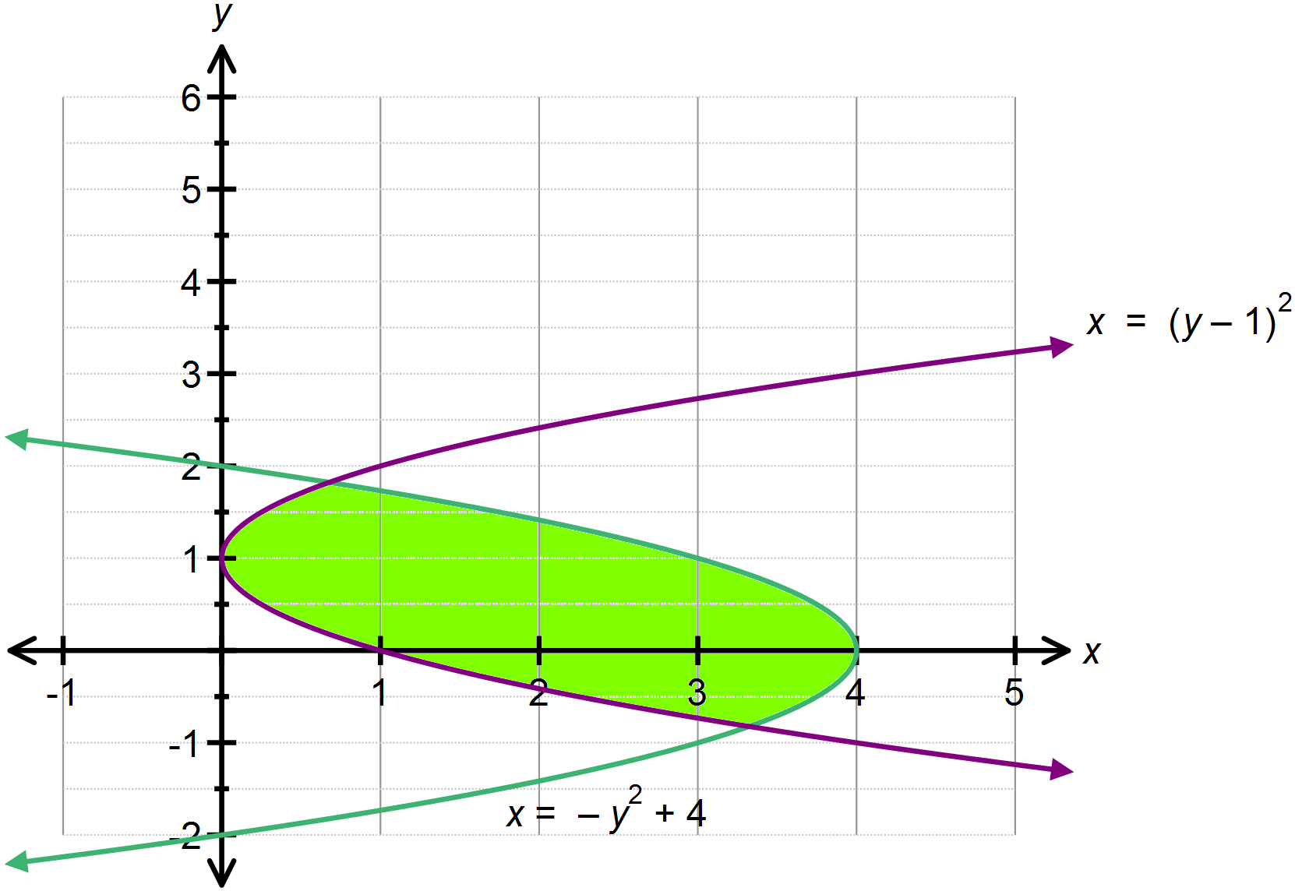

**Question 10 (4 marks)**

Show that $\int_{1}^{2}{\left(\frac{6x+4}{\sqrt{x}} \right) dx}=16 \sqrt{2}-12$.

*(Show sufficient work out please and use* ***exact*** *values)*

**Question 11 (3 marks)**

The area under the curve  over the domain  is  .

Determine the value of *k* , given that $-1≤k≤1$.

**Question 12 (4 marks)**

The area bound by the parabola $y=6x^{2}-6x,$ the $x$– axes and the lines $x=1$ and

$x=c, (c>1)$ is equal to 1unit². Find the value of the constant $c$.

END OF PAPER 2

EXTRA PAGE FOR WORK OUT